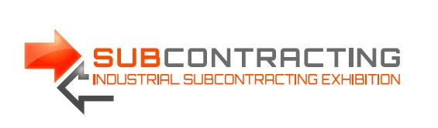

Subcontracting ITM Meetings among seven awarded events organized by EEN
The annual conference which summarizes the activities of the Enterprise Europe Network was held 20th-22nd November 2017 in Tallinn. It summed up the results of the events held by the EEN in 2016. Out of 324 events organized by EEN centers, seven best events were chosen and the methods of organizing the awarded events were given as best practices to be followed - among them were Subcontracting Exhibition along with Subcontracting ITM Meetings!
Below is the list of the categories and results:
- Most meetings per participant: 18.7
- Most participants: 1364 from most countries: 59
- Most B2B participants: 760 and most meetings: 3,326
- Largest share of participants actively selecting partners: 79%
- Largest share of participants of the previous edition, who registered for the forthcoming one: 61.6%
- Most mailings: 67 and resignations being a result of no-match meetings: 107%
- Most feedback on the post-meeting satisfaction survey: 100%

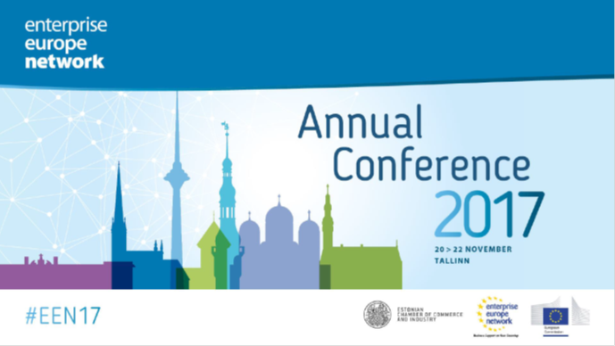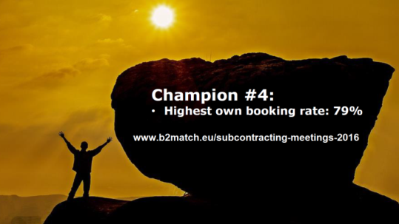

Among the honored events were Subcontracting ITM Meetings 2016, organized by the Poznan International Fair in cooperation with an EEN member, Poznan Science and Technology Park (PPNT), Adam Mickiewicz University Foundation.
The Poznan matchmaking meetings were awarded for the best event related to activation of participants. Where real business is concerned no-one is waiting for prince charming. It is best to choose a business partner carefully and on one’s own. As many as 79% of the participants of Subcontracting ITM Meetings decided to be active and invite potential partners for a meeting instead of passively wait for an invitation. When asked about the source of success, Coordinator of Poznan Subcontracting ITM Meetings Barbara Kamińska listed 3 most important reasons without any hesitation:
- “Making use of hints provided by experienced colleagues from EEN: Thomas Roeblreiter from Veinna’s FFG and Grzegorz Cieśla from Poznan’s PPNT.
- Using every contact in order to educate participants about taking advantage of matchmaking potential, i.e. how to describe one’s company and how to properly select partners for meetings
- I love doing that ”

The efficiency of matchmaking meetings is best proven by their dynamic development. The 2016 edition included 290 meetings and 76 participants from 10 countries. The Subcontracting ITM Meetings 2017 saw 322 meetings among 117 participants from 15 countries.
Matchmaking meetings are like a dating agency which conveniently pairs business offers with customer expectations. However, instead of the age, measurements and interests, the partners are matched according to performance, output capabilities and certificates owned.
The forthcoming SUBCONTRACTING ITM MEETINGS will take place 6-7 June 2018. Feel invited to register through www.subcontracting-itm-meetings-2018.b2match.io. The meetings have been an integral part of the largest industrial trade fair in Central and Eastern Europe ever since 2013. Next year, from 5th to 8th June 2018, five trade shows such as ITM POLAND, SUBCONTRACTING, FOCASST, 3D SOLUTIONS and MODERNLOG will lead the participants towards 4.0 industry.

